Week 11 – Social Engineering

Essential Terms
- Identification = process by which system entity provides a claimed identity to the system, for example a user ID like Alice or Bob or 93123.
- Authentication = process of verifying an identity claimed by or for a system entity, for example using a password.
- Authorization = granting of a right or permission to a user or system entity to access a given resource.
- System entity = user, program, device ...

Authentication Factors
Three means of authenticating user identity (a.k.a. user factors) are based on:
- Something you know (e.g. password, user ID, answers to verification questions)
- Something you have (e.g. security ID, smart card)
- Something you are (e.g. biometrics, face detection)

Something you know
- Users gain access based on something they know
- Password based
  - Must kept secret
  - Easy to recall
  - Unique
  - Should be long and complex
- Password Weaknesses
  - Not very secure due to poor choice of passwords
  - Human beings can memorize only a limited number of items
  - Security policy enforcement doesn’t help
Examples: 10 most used passwords

Passwords: First Approach
- Verifier (server) simply compares user ID and password already stored in file to user ID and password sent by claimant.

Passwords: Second Approach
- Verifier (server) stores user ID and hash code of password in file, does comparison by hashing sent password and comparing with already known hash

Passwords: Third Approach
- Verifier stores salt (random data to differentiate between duplicate passwords), hash of salt and password (concatenated together), and user ID; compares it to everything sent by claimant
- Note: salt is randomly generated for each password

Salting and Hash: Loading Password
- Salting: idea is to increase attacker workload by increasing the complexity of the hash and differentiate between duplicate passwords
- Salt = pseudorandom or random number
- User supplies password
- Hash applied to concatenation of salt & password
- Store user ID, salt and hash in the password file (or database)
- Password is not stored!
- Password files often hidden (shadow passwords in Unix, only accessible to system admin)

Salting and Hash: Verifying Password
- User provides their ID and password.
- Lookup the salt and hash.
- Recompute the hash using the supplied password plus salt.
- Does the recomputed hash equal to what was expected?
- Note that this scheme never reveals the password to anyone, even to system admin

Password Cracking
- Brute force Attack
  - Attempt on every possible combination of letters, numbers, and characters
  - Create candidate digests (called rainbow table) for matching
  - Computation intense
- Dictionary Attack
  - Begins with creating digests of common dictionary words or their mutations
  - e.g. p@ssw0rd, Luv4Eva
  - Intelligent cracker tool will apply those mutations automatically
  - Password dictionaries (containing passwords that are either very popular or were captured during previous attacks) also can be used.

Two Factor Authentication (2FA)
- Two factor because “what you know” (password) + “what you have” (device)
  - Enter password, sent text message with special code and must enter this to complete verification
  - Can also be a token (SecureID etc.) that automatically generates special code
  - Or an app on your phone (Google authenticator)
- Special code is a one-time password
  - Never used twice.
  - Randomly generated.
- Generalised to multifactor authentication (MFA).

Something you have
- Users gain access based on presenting something they have
- Something human owns that can authenticate the holder
  - For example, Security Card, Security (hardware) tokens
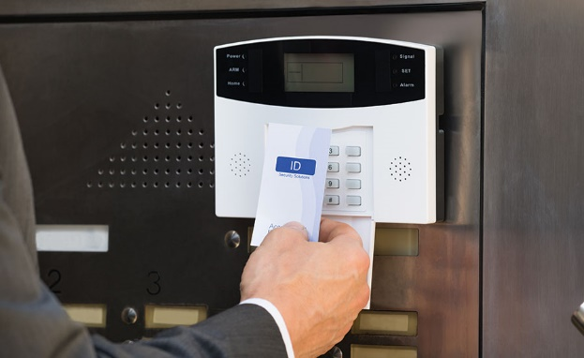

Something you are (biometrics)
- Users gain access based on something they are (either physiological or behavioural features)
- Based on pattern recognition
- Is technically complex and expensive when compared to passwords and tokens
- Becoming more common due to fingerprint readers etc. being built into mobile phones.

Biometrics

Biometrics: how it works
- Pattern recognition.
- Face: relative location and shape of key facial features.
- Fingerprint: furrows and ridges.
- Hand geometry: shape, lengths and widths of fingers.
- Retinal pattern: veins illuminated by low-intensity beam of light.
- Signature: writing habit, pressure, shape of signature, will vary over time (dynamic).
- Voice: based on anatomy and physical characteristics, will vary over time as well (dynamic).
- NOT 100% ACCURATE UNLIKE A PASSWORD

Central Authentication
- Also called Single Sign-On (SSO)
  - Allows users to access multiple services with a single login
  - Provides a single access to multiple systems within a single organisation
- Phase 1: Requires user to login to an authentication server
  - Checks id and password against a database, then a certificate
- Phase 2: Certificate used for all transactions requiring authentications
  - No need to re-enter passwords, Eliminates passwords changing hands

Kerberos (3rd Party Auth)
- Is an authentication server that acts as a third-party authenticator
  - Helps the user to prove its identity to the various services
- The three heads:
  - Auth: Confirms that a user who is requesting services (user certificate)
  - Authorization: Grants specific types of service to a user based on their auth ticket
  - Accounting: Logs ticketing of the consumption of network resources by users


OAuth Shift
- Moving enterprise authentication server to the Web
- Called as HTTP-based Single Sign-On
  - Similar in spirits with Kerberos, OpenID, SAML
- Strictly speaking, it’s a Federated Identity
  - Provides a single access to multiple systems across multiple organisations
- Open Standard allows Internet users to log in to 3rd party websites
  - Sign into their accounts through Google, Facebook etc.,

OAuth Benefits
- Authentication and Authorization provided by third party Service Provider
- Application developers can focus on building an app, not an authentication framework
- Username and password are not processed by application
- User identification is collected by service provider
- Improves Usability and security
- Centralized management of user accounts
- Users don't need to create separate account for each application/service
- Fewer identities & passwords to remember

OAuth Service Providers and Clients
- OAuth Service Providers:
  - Google: For web access to Google APIs
    - Google+, Drive, AdSense, Analytics, and many more...
  - Twitter; Twitch: Web and Streaming (real time) APIs
  - Facebook: Using Graph API (i.e. a low-level HTTP-based API) to get data in and out of Facebook’s platform
- OAuth Clients:
  - Websites: CNN, Washington Post, Kickstarter, etc
  - Mobile apps and games:
    - According to Facebook, 81 of top 100 grossing iOS and 62 of top 100 grossing Android apps use Login with Facebook
  - Anything with a “Log in with Facebook/Twitch/Google/3rd party client” option
